**

# **Department of Computer Science and Engineering**

# **Course Code: CSE200**

# **Course Title: Computer Aided Engineering Drawing**

# **Section: 09**

# **Project Topic: Hatirjheel 3D MODEL**

# **Submitted By:**

# **Sheikh Sarafat Hossain (2022-3-60-109)**

# **Rijia Parveen Raya (2022-3-60-192)**

# **Md Shahmul Islam (2022-3-60-154)**

# **Mehejabin Khan Juju (2022-3-60-003)**

# **Submitted To:**

# **Md. Mafiul Hasan Matin**

# **Title:** Engineering Drawing Project Report: Design and Construction of Hatirjheel Bridge Over Water Surface with Basic Tree

## Introduction:

This report highlights the process of creating a 3D model of Hatirjheel Bridge over a water surface, with basic tree nearby using AutoCAD. Various tools and commands including line, arc, sweep, extrude, thicken, mirror, and additional techniques were used to draw the project in AUTOCAD.

## Project Objective:

The primary objective of this project was to apply engineering drawing principles and AutoCAD skills to construct a detailed 3D model of Hatirjheel Bridge, a prominent landmark in Dhaka, Bangladesh.

**STEPS:**

# 1. Research and Preparation:

Conducted through research on the structural components and architectural aspects of Hatirjheel Bridge. Gathered reference images and technical specifications to guide the modeling process.

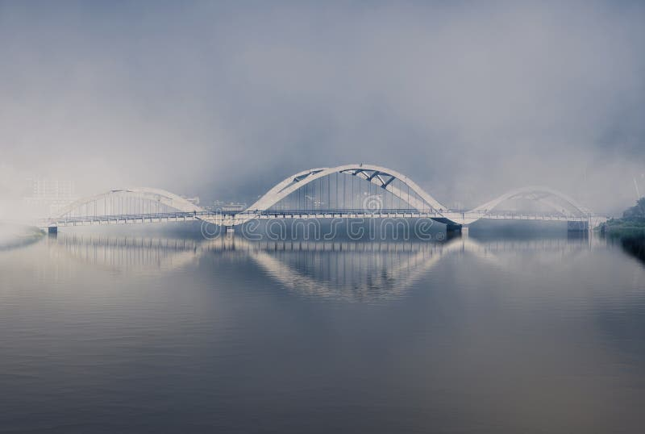

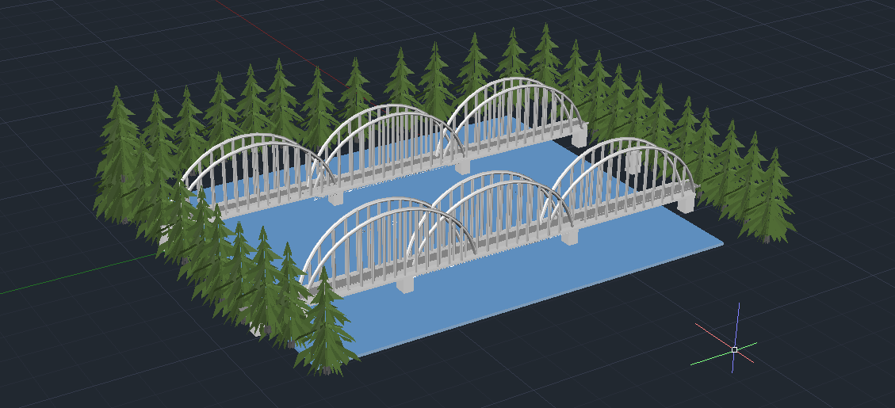

# 3. AutoCAD Modeling:

**Hatirjheel Bridge:**

Utilized the line and arc commands to create the outline of the bridge deck and arches. Employed the sweep command to generate the bridge railings and other linear features. Used extrude and thicken commands to give depth and volume to the bridge components. Implemented the mirror command to ensure symmetry in the design of the bridge.

**Basic Tree:**

Started with a simple line representing the trunk of the tree. Utilized arcs and lines to sketch the outline of branches and foliage. Employed the sweep command to create 3D branches from 2D sketches. Used the extrude command to add volume to the trunk and branches. Applied the mirror command to ensure symmetrical distribution of branches.

**Review and Refinement:**

Regular reviews were made to improve the model's proportions, scale, and color application. Color gradients and shading were adjusted to achieve a visually balanced image.

**Conclusion:**

Through the utilization of AutoCAD tools such as line, arc, sweep, extrude, thicken, and mirror commands, a detailed 3D model of Hatirjheel Bridge and a basic tree was successfully constructed. This project not only demonstrated proficiency in engineering drawing principles but also highlighted the versatility of AutoCAD in translating design concepts into concrete models.